Mean Value Theorem and Intermediate Value Theorem notes:

MVT is used when trying to show whether there is a time where derivative could equal certain value. In this case, after you verify that the function is continuous and differentiable, you need to check the slopes of points that are given to see if the desired tangent slope value matches any of the secant slope options.

Example:
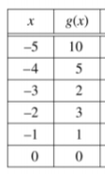 | 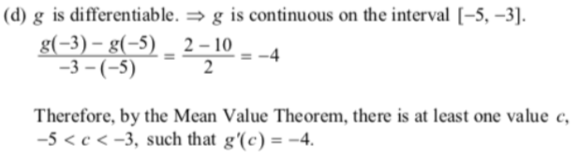

IVT is used when trying to show whether a function has a specific value. In this case, you only need to verify that the function is continuous and that the surrounding y-values exist within the specified interval.

Examples:
