AP Test Prep Questions, Week 3
All of the following questions are NonCalculator.

2006, Form B, #6
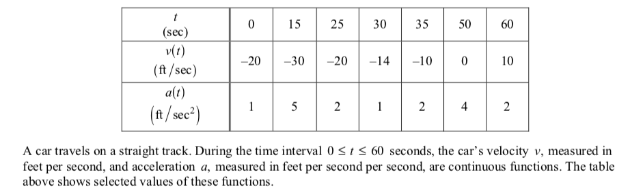
- Approximate $\int_{30}^{60}{\left|v(t)\right|dt}$ using a trapezoidal approximation with the three subintervals determined by the table.
- Find the exact value of $\int_{0}^{30}{a(t)dt}$.

2006, Form B, #5
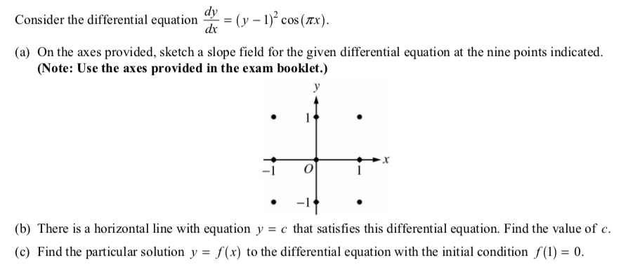

2013, #4

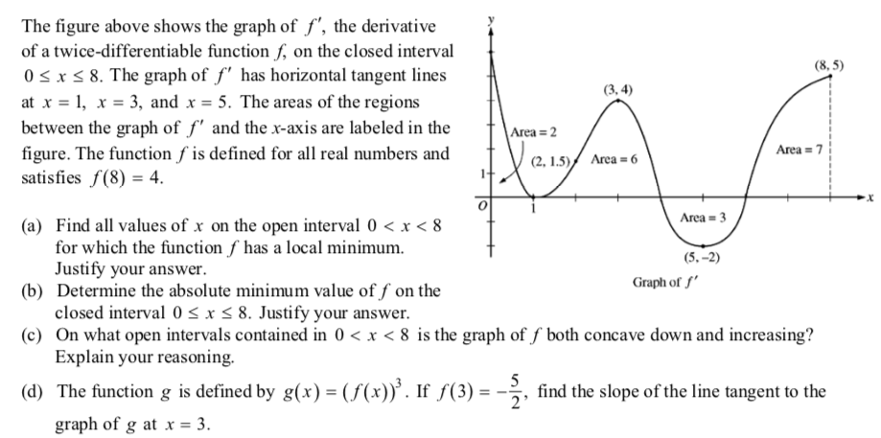

2019, #6
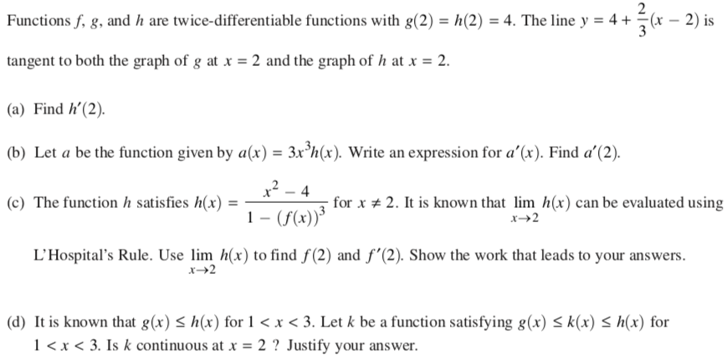

2014, #5
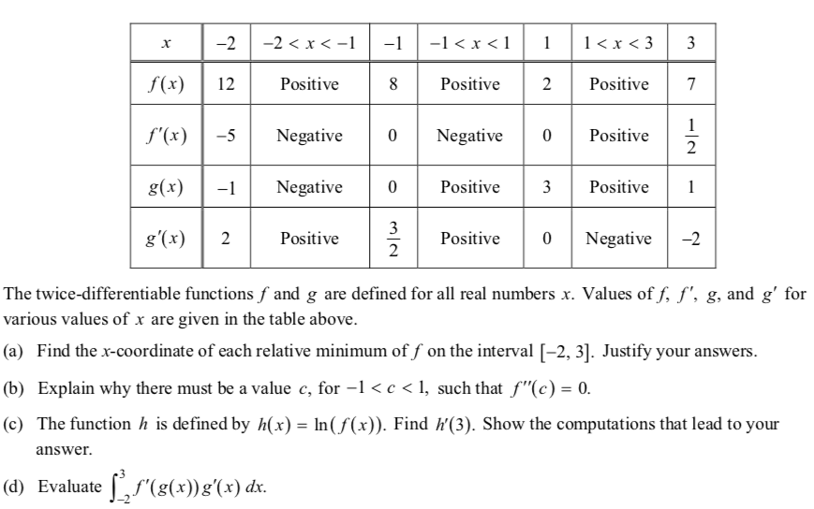

2006, Form B, #6
- Approximate $\int_{30}^{60}{\left|v(t)\right|dt}$ using a trapezoidal approximation with the three subintervals determined by the table.
- Find the exact value of $\int_{0}^{30}{a(t)dt}$.
(a)
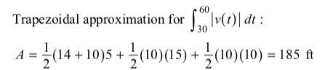

(b)
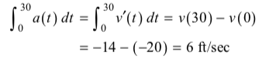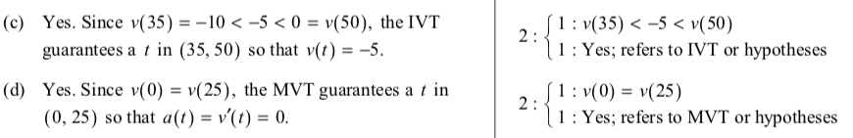

2006, Form B, #5
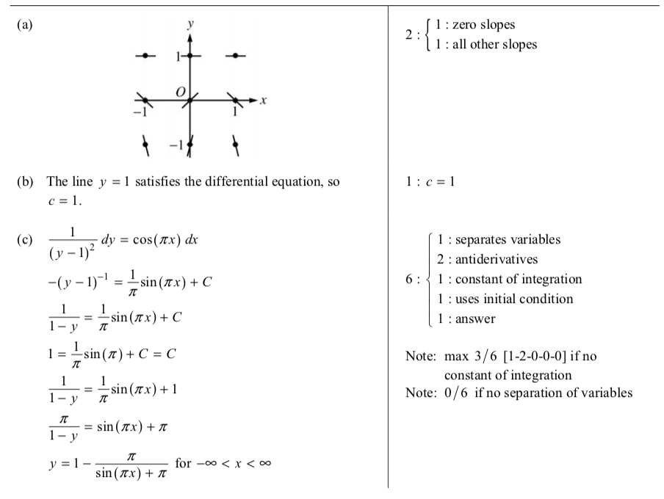

2013, #4

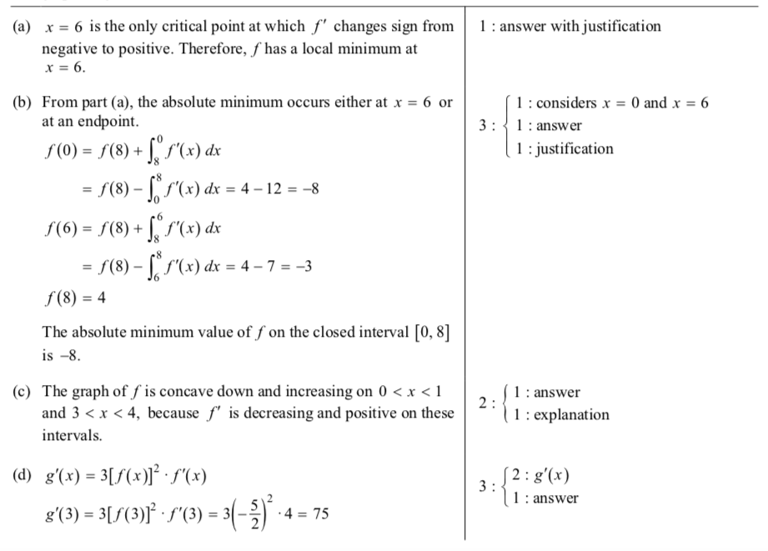

2019, #6
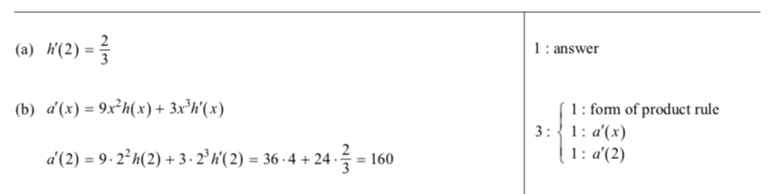
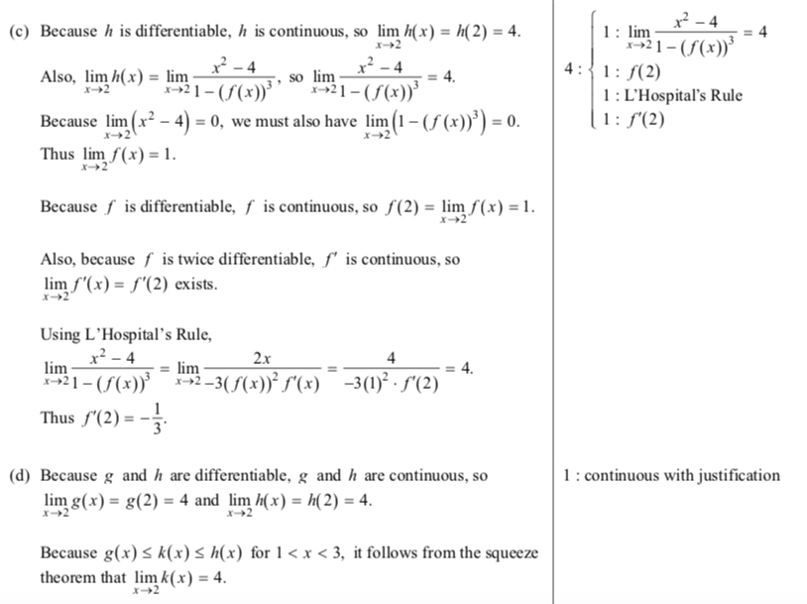

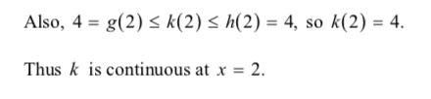

2014, #5

