**AP Test Prep Questions, Week 2**

All of the following questions are NonCalculator.

**2019, #3**

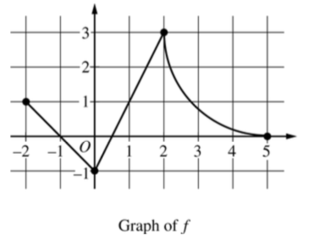

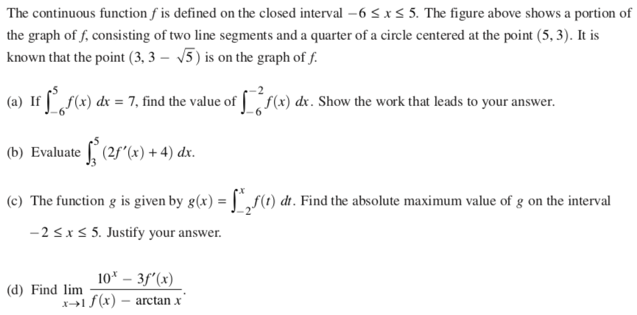

**2019, #4**

|  |  |
| --- | --- |
|  |  |

**2009, #5**

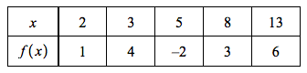

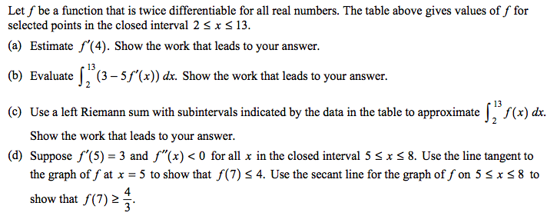

**2015, #6**

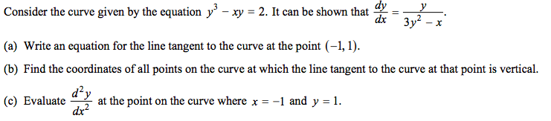

**2017, #6** *We did this problem already for hw in our composition book. Feel free to redo it, as there are certain things I want to highlight about this problem during the video session.

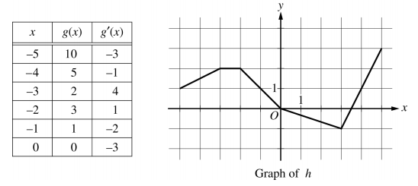

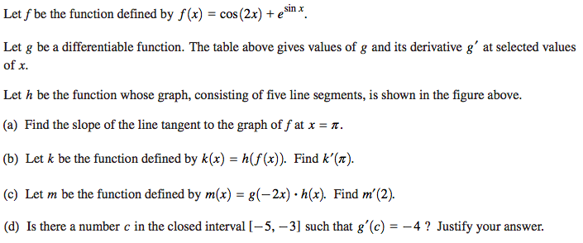

**SCORING GUIDELINES**

**2019, #3**

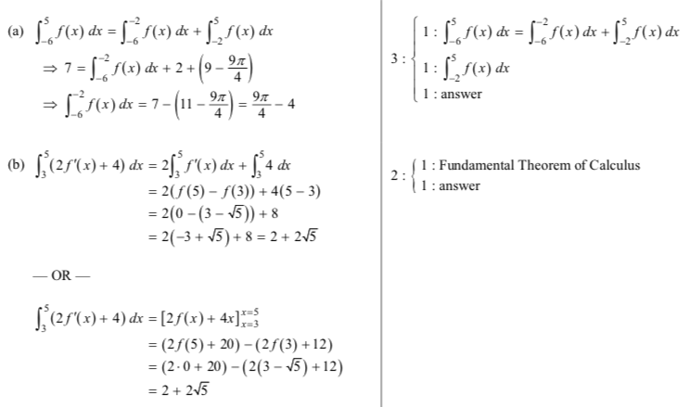

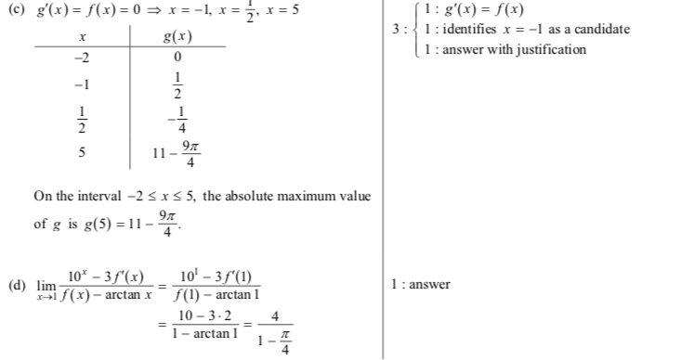

**2019, #4**

|  |  |
| --- | --- |
|  |  |

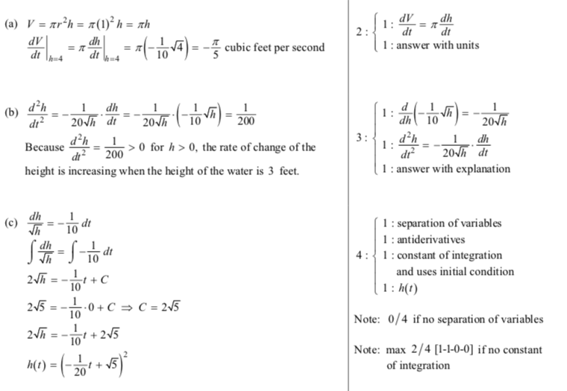

**2009, #5**

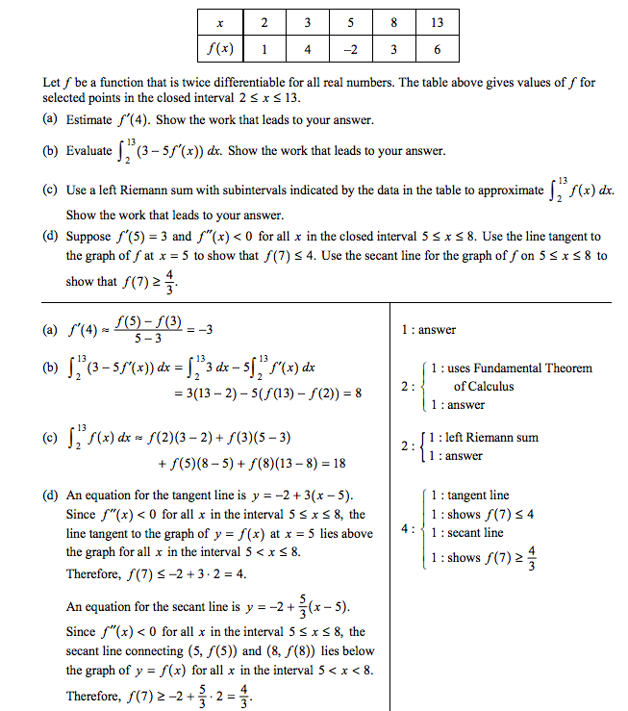

**2015, #6**

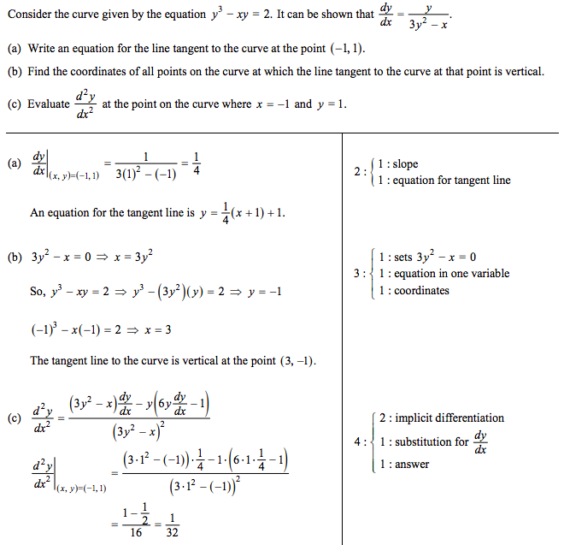

**2017, #6** *We did this problem already for hw in our composition book. Feel free to redo it, as there are certain things I want to highlight about this problem during the video session.





