All of the AP Questions below are noncalculator.

2012 #4
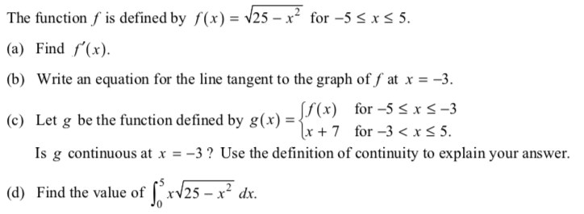

2012 #5
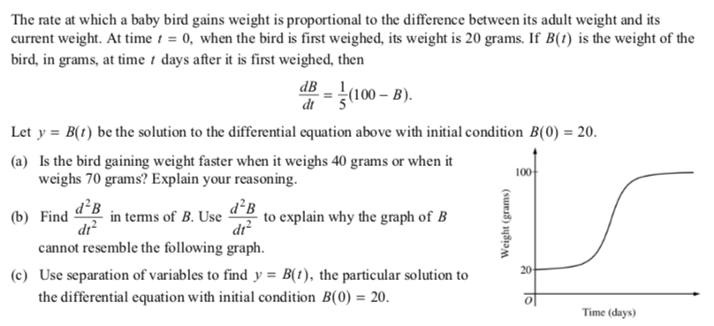

2016 #3
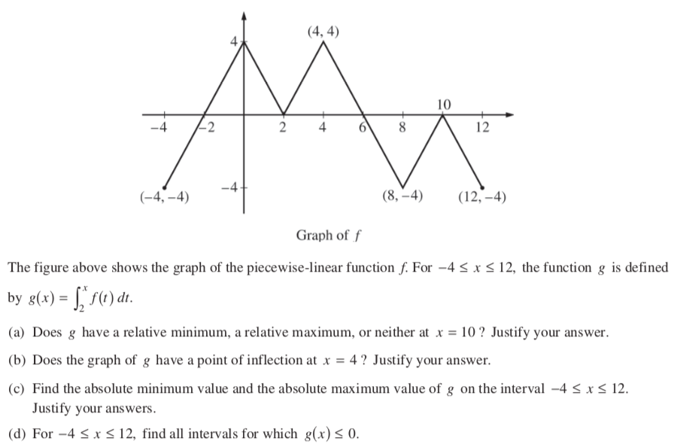

2017 #5
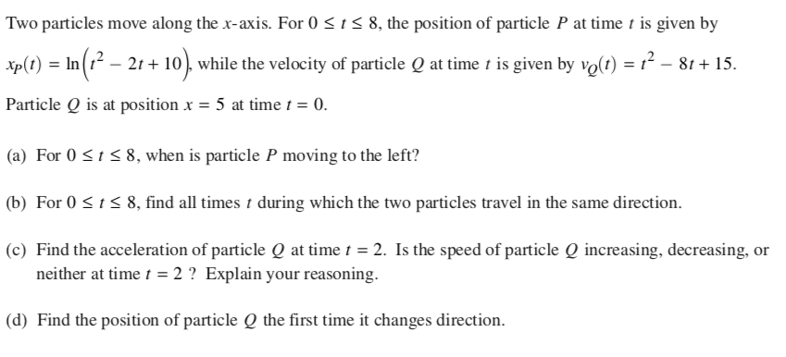
*Note that part (d) can be solved with antiderivatives or start+accumulation from Lesson #85/86. That video lesson can be found on course website. Part (d) would not be on the 2020 AP test.

Scoring Guidelines
2012 #4
_________________________________________________________________________________________________________________________
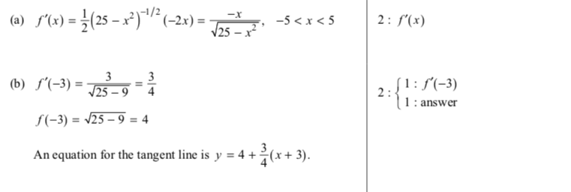
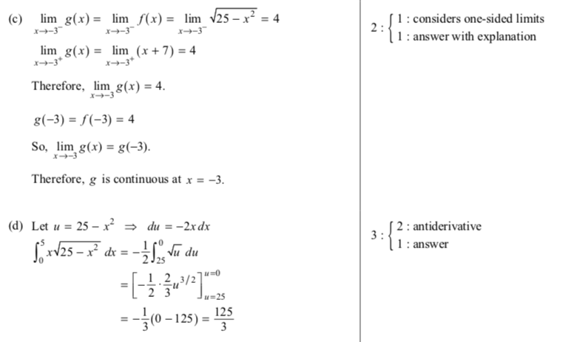

2012 #5
_________________________________________________________________________________________________________________________

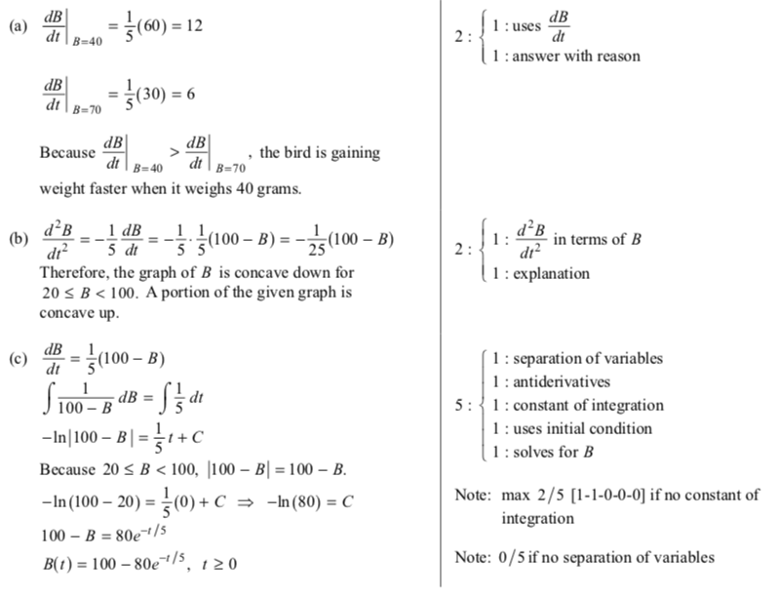

2016 #3

________________________________________________________________________________________________________________________

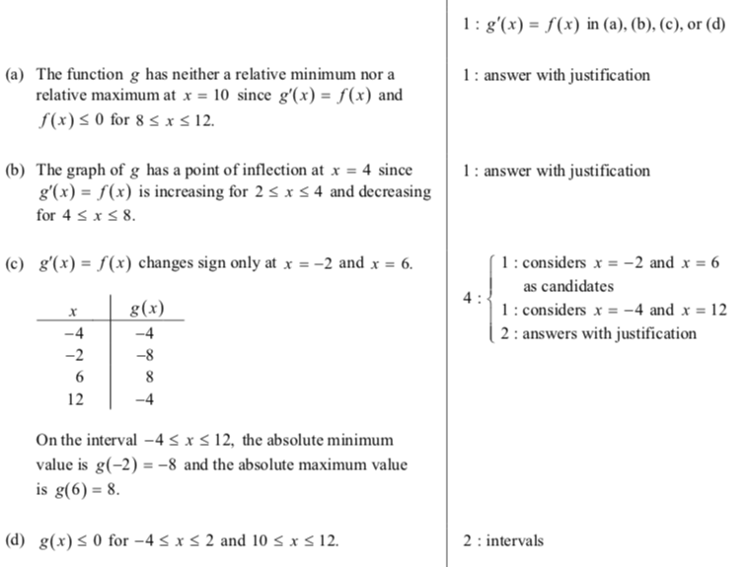

2017 #5
*Note that part (d) can be solved with antiderivatives or start+accumulation from Lesson #85/86. That video lesson can be found on course website. Part (d) would not be on the 2020 AP test.
_________________________________________________________________________________________________________________________

